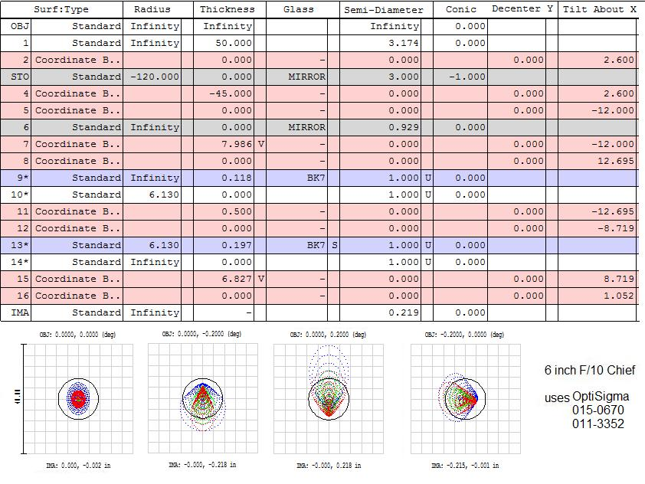
Tolerances
What | How much | compensators | Strehl
nothing | N.A. | none | 0.952
lens2/image space | 0.125 | diagonal/lens1 space | 0.879
lens2/image space | 0.125 | diagonal/lens1 space + lens group tilt | 0.952
lens2/image space | 0.5 | diagonal/lens1 space + lens group tilt | 0.942
lens1/lens2 radius | "-.1226/+.1226 | diagonal/lens1 space, focus, lens group tilt | 0.903
angle between lenses | +.5 deg. | focus, lens group tilt | 0.931
decenter lens group | 0.125 | focus, lens group tilt, lens1 space | 0.94
decenter lens1 Y | 0.05 | focus, lens group tilt, lens1 space | 0.645
decenter lens1 Y | 0.017 | focus, lens group tilt, lens1 space | 0.817
decenter lens1 X | 0.017 | focus, lens group tilt | 0.804
primary tilt | .25 deg. | focus, lens group tilt | 0.878
primary radius | "4% or 4.8 in | focus, lens group tilt | 0.931
lens1 tilt | .17 deg. | focus | 0.81
lens2 tilt | .29 deg. | focus | 0.808

